A class is an attribute is a name given in HTML, CSS or JavaScript where a group of like objects are given a reference name, to group like things together e.g. different types of fruit. We would class them all like this inline in HTML:

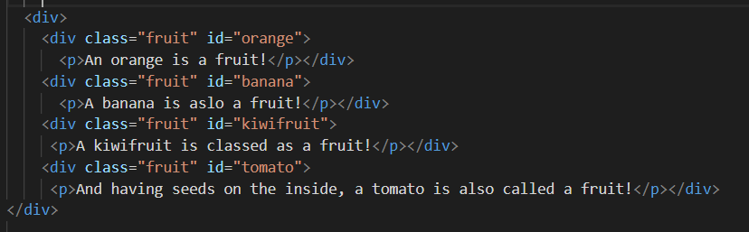

**Figure 1. Inline styling showing class & id**

If you’re in the CSS, you would use a dot (.) in front of the name to decipher that this would be for a styling set of instructions for a class (in this instance called fruit)

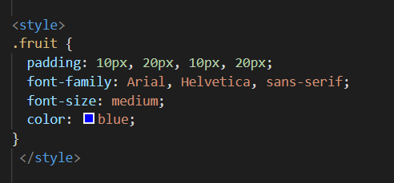

**Figure 2. – Class uses . before the class name**

An ‘**id**’ is given to an attribute to decipher it’s difference among the class – refer back to Figure 1. All the fruit are grouped together in a class called ‘**.fruit**’ but we can also identify what each individual fruit is called. E.g. ‘**id=orange, banana, kiwifruit or tomato**’ By using the unique id in the CSS, we refer to an id using the # symbol in front of the id name. By doing this, we can manipulate the styling for that individual **id** as well as keeping the styling the same for the entire class.

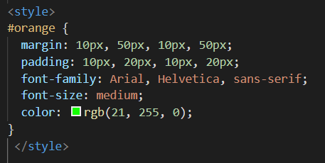

**Figure 3 – id uses Hashtag Symbol**